**Internet of Things for Precision Agriculture Applications**

Sukhwinder Singh  
Computer Science and Engineering Department  
Thapar Institute of Engineering and TechnologyPatiala, Punjab  
sukhsinghturka02@gmail.com

Sanmeet Kaur  
Computer Science and Engineering Department  
Thapar Institute of Engineering and TechnologyPatiala, Punjab sanmeet.bhatia@thapar.edu

Parvez Alam  
Computer Science and Engineering Department  
Thapar Institute of Engineering and TechnologyPatiala, Punjab  
alam11parvez@gmail.com

Parteek Kumar  
Computer Sceince and Enginerring Department  
Thapar Institute of Engineering and TechnologyPatiala, Punjab  
parteek.bhatia@thapar.edu

s

*Abstract*— Precision agriculture is an innovative technique that encourages the use of Information Technology devices to produce high-quality yield with the best utilization of available resources. Presently, the practice of precision agriculture has become more common due to the inclusion of varied technologies and communication mediums. This technique can be acquired by farmers to optimize their crop returns with proper preservation of resources. This study proposes a Platform to measure soil and environmental parameters such as humidity, temperature, and moisture of the soil. In contrast, the population is increasing in an inclined order, to keep an eye on the growth level of the population level and requirement of the food resources, the researchers are still struggling for the dataset availability of their region. Thus, a need to measure crop parameters for analysis was felt. This study uses Raspberry Pi, Sensors and other information technology-based types of equipment to fetch the data and readings of the soil and environment. Further, a methodology has been devised which uses a cloud platform, for real-time analysis of the data gathered from the proposed platform. This analysis includes several plots that are based on the readings of the sensors from the station. The upshot of this study is the possibility that the researchers could implement the model using the observed reading from the soil and environment and it could also be aggregate, visualize and analyze the live stream of data for their local region. The study could further be used as a foundation for implementing precision agriculture models such as unmanned aerial vehicle-based precision farming.

Keywords— Internet of Things, precision agriculture, WSN, Sensor-based irrigation, Big Data analytics.

# Introduction

The world`s 70% fresh water is consumed by agriculture. The production of the food must increase by 70% to 2050, and this has to be achieved in spite of limited arable land, unpredictable rainfall, and change in the life cycle of many plants. There is a need to do smart irrigation which will allow the user to utilize agriculture-based available resources like water in a smarter way. Agriculture and IoT are two big things, one has a history due to which humanity exists and the other one is the latest technology to make life easier and comfortable for mankind. Sensor-based technology is added to the strong network through which the world is connected to other networks and it is one of the biggest booms in the industry of Information Technology. Many applications use sensors based technology which produce a huge amount of data such as DateTime, reading values and longitude of observation, it increases in veracity and volume of data that leads to the huge amount of data creation, but the cloud provider embedded with the IoT sort the data as per requirement. IoT refers to the interconnected network of everyday objects, which are often equipped with ubiquitous intelligence. IoT will increase the ubiquity of the Internet by integrating every object via embedded systems, software, sensors, and actuators (motors) for interaction.

In India, the irrigation industry is one of the major sources of employment and there are lots of crops such as rice, tea, wheat and etc. are exported to other nations like Australia and Bangladesh. But still, there is no modern technology is used to make the work at farms efficient and easy with the minimum usage of available resources. In the present-day scenario, a person is hired by the farmer to keep an eye on the crops and availability of the resources, but it is not an efficient way of irrigation. Sometimes water more than required is given to the fields and in other aspects, the rainfall occurs just after the irrigation is done, which decreases the productivity of the crop and nutrient level of the soil.

The proposed system helps the owner of the farm to tackle the difficulties of agriculture in a smarter way and yield good quality and quantity of the crop with minimal use of electricity and water. It provides information about different environmental parameters such as temperature, moisture, and humidity. These fetched observations can be analyzed using online tools. A thingspeak is a famous online tool and an API is used to import/ export data from online resources such as HTML, HTTP, and the local network. The imported data can be analyzed by the user at any time without any cost. Thingspeak has connectivity to the Mathworks, which provides the analytics services of a dataset. Users can analyze the data using any model of machine learning tools. The main elements of thingspeak are data analysis, predictions element counter and weather forecasting.

This study would be helpful for irrigation in a country like India where the farmers still use the older ways of farming and employing a maximum number of people in it. This method can be applied to a testbed using a proportional of the land at home as experimentation. A testbed is consisting of random samples of a particular farm and collectively used in a pot to understand the behavior of the soil. The results of the testbed can be used to make an Automatic and remote irrigation system that provides help to the farmer by giving the remote access of the farm.

The rest of this paper is structured as follows: Section 2 presents the literature review of existing approaches based on WSN. In Section 3, devices for implementation of this study and the proposed framework is discussed in detail. The experimental results and discussions have been depicted in Section 4. Finally, the conclusion and future scope of this study are presented in Section 5.

# Literature Review

In this section, recent developments in the usage of WSN, BigData, and decision analytics for precision agriculture has been discussed. These studies use the different values of water usage, soil moisture, humidity, precipitation and other parameter related to the crop.

Kumar and Rmudu (2019) developed a decision support system for precision agriculture. An IoT framework that consists of sensors for measuring humidity, temperature, soil moisture, and the rain was prepared to collect real-time information of a field to take the right decision for the crop. This study is beneficial in maximizing the crop yield by optimizing the usage of water and fertilizers [1].

Andrew et al. (2018) showcased the two feasibility studies on IoT framework for automated irrigation and animal monitoring. The study used WSN to fetch the data of the environment and soil. Big data was used to analyze the dataset collected from the fields. The production of the crops was subsequently improved in the case of automated irrigation and the abnormal behavior of animals is predicted in automated animal monitoring [2].

Dholu and Ghodinde (2018) proposed an IoT framework in the agriculture domain. The proposed system uses different sensors for humidity, temperature, and soil moisture measurement. The observed values of all these sensors are fetched using the raspberry device and directly uploaded to the cloud server, where the readings are further analyzed to increase the productivity of the crop [3].

Bakshi and Thakur (2016) developed a model along with cloud services. The model collects information about different environment parameters such as soil, humidity, temperature and etc. Further, based on some threshold values for each parameter, the control decision of switching ON/OFF a fan/cooler is taken [4].

Khot and Gaiwad (2016) studied the usage of light intensity system in precision agriculture. Light intensity and humidity information were collected using different sensors, and the fetched information was directly uploaded to cloud storage. An automated decision was taken based on these readings. This study resulted in an increased level of the growth of plants comparatively to the traditional scheme [5].

# methodology

This proposed study mainly deals with the sensors networks installed within the farm. The experiment is conducted using sensors and other devices on a testbed. A testbed is like a randomly chosen sample of soil from the field. The whole chosen samples are combined and collectively use in a cemented made pot having weight up to 2 KG. The pot contains 80 percent of the soil and the remaining 20 percent is used for watering and the air-inhaling to plant and the soil. In the pot, a plant is also seeded that can be assumed as a plant of a crop to measure different types of activities such as respiration, photosynthesis and etc. Hence, this testbed is used in this experiment to understand the working of the plant and the soil. The working of the proposed system is consists of multi-fold. Firstly, it uses sensing technology to make the pot more intelligent and more connected through precision agriculture. Secondly, the system provides information about different parameters of soil and environment to check the moisture level and the temperature of the irrigation field. Thirdly, it has a cloud platform to store and send multiple sensors data values, signals between the user, and sensors. Lastly, it ensures that the minimum moisture level is maintained in the irrigation. In this study, hardware and software devices are used to perform the experiment. These required equipment are discussed in the next part. Components used for undertaking the methodology: There are several components used to develop the prototype of this experiment. Several devices used in this study are depicted below.

* Raspberry Pi model 3B

This device has a mini-processor of 1.4Ghz, 1 GB Ram, 4 USB ports, 40 multi pins and many more. It is connected to the end nodes of the experiment such as sensors. It connected to the sensors and publish their reading. This component is working as a slave node in this study.

* Raspberry Pi model Zero W

It is like a mini-computer device that enabled with different memories such as RAM, HDD, and a quadcore processor. This is a master device that used to perform the operation between end nodes. This device subscribes to the information from all the nodes using unique wi-fi connectivity and publishes them to the public cloud server.

* DHT11 sensor

Humidity sensors detect the relative humidity of the particular environment. Humidity around the crop is a key parameter for not only the growth of crops but also as a strength level of the soil. It is similar to the temperature measurements, as the air becomes hotter, it holds more moisture, so the relative humidity changes with respect to temperature. Apart from fetching the humidity readings, it also fetches the temperature record of the environment.

* Soil moisture sensor

The Soil Moisture Sensor is used to measure the loss of moisture from the soil over time due to evaporation and plant. The soil moisture sensor evaluates the optimum soil moisture content for various species of plants and control irrigation in greenhouses.

* DS18B20 sensor

It is a single wire programmable Temperature sensor. It measures a wide range of temperature from -55°C to +125°C with a decent accuracy of ±5°C. The sensor requires only one pin of the MCU to transfer data for measuring the temperature at multiple points without compromising with digital pins on the microcontroller.

* MCP-3008

The MCP3008 is a 10-bit ADC (Analog-to-Digital Converter) device, that combines high performance and low power consumption in a small package, making it ideal for embedded control applications. It is used extensively with Raspberry Pi for interfacing various analog sensors with a raspberry pi device and convert an analog signal to digital information. An example of a device is depicted in Figure 1.

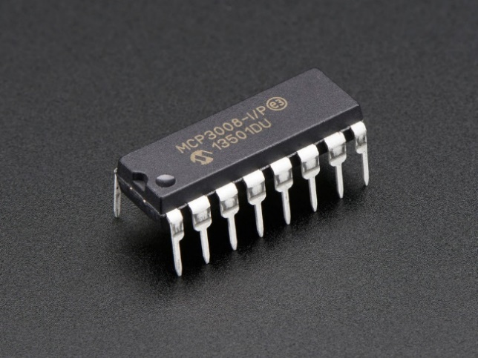

Figure 1: A simple ADC convertor.

* Putty

It is an open-source windows-based software application that provides connectivity between clients and servers. In this experiment, the clients are sensors which fetching and exporting the information from the soil and environment. The raspberry device is called as a server, which subscribes the information between both end nodes. It helps both nodes to work simultaneously and transform the information from different sensors.

* Advance IP scanner

It is a software tool used to import information about the different types of Wi-Fi enabled devices located nearby to the Wi-Fi server. It lists out with all multiple devices with their Wi-Fi address and the MAC address.

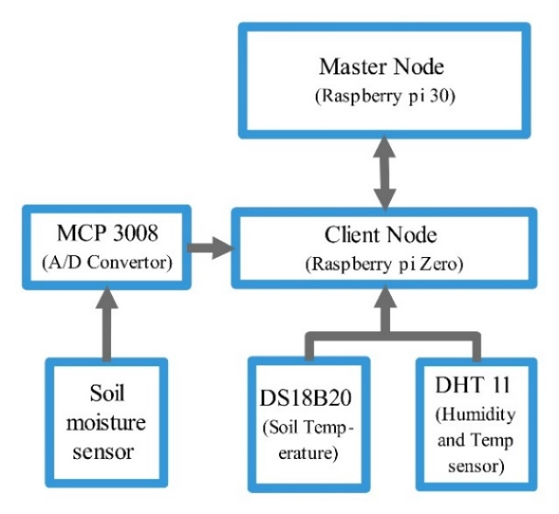

Figure 2: Architecture of the system.

Working of the System: The fundamental concept of the work is expressed in Figure 2, several components related to the experiment namely temperature and humidity sensor, soil moisture sensor and soil temperature sensor. Apart from these devices, several other hardware devices are connected such as raspberry devices (zero and 3B) and an ADC. The architecture in the figure clearly depicts the working of the experiment. A flowchart of the proposed study is also drawn in Figure 3. Initially, all types of equipment are arranged in the best way to increase the flow of data transmission. Sensors such as soil moisture, soil temperature are installed in a pot to fetch the properties of the soil and these are further connected to a raspberry pi zero device. These installed soil-based sensors are depicted in Figure 4(a). Another two sensors such as humidity and the atmospheric temperature are installed on the cabinet body of the module, the cabinet looks like a box where a raspberry zero device kept with its all connected device, it is depicted in Figure 4(b). These devices are powered by a 9volt power battery to communicate the information of soil and the environment.

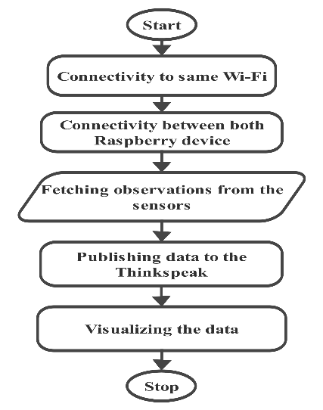

Figure 3: Algorithm of the study.

A powered connection between all devices using a battery is set up and an end to end communication channel with a single Wi-Fi is created for sharing the information. The Wi-Fi address of all the nodes is setup using an advanced IP scanner tool. IP Tool fetches the information of all the nearby Wi-Fi devices and their MAC addresses. Several devices can be recognized using their Wi-Fi address. In the communication channel, the raspberry Zero device collectively shares the information of all the connected sensors with their reading and exports it to the raspberry 3B device. This Raspberry device subscribes the information of all the sensors. Channel fetches the reading from the sensors and publishes it the server using the same Wi-Fi connectivity. A unique Wi-Fi device must require to connect the multiple devices to a single raspberry device. In the experiment, there is a constraint of Wi-Fi, if any sensor or device has not connected to the same network then the device may be lost.

The putty application is used to create a connection among all devices. All devices are enabled using the Putty software and the flow of the information is starts communicating from the sensor nodes. The raspberry pi-zero collects data from all sensor nodes and collectively export to the Raspberry Pi model 3B, through which it directly shares to the server of the thingspeak.com. The thingspeak keeps the records of the observations from all different sensor and publish these on the client-side to analyze the results. The observations from all different sensors can be analyzed online from the thingspeak server. (thingspeak. com/ channels/744022).

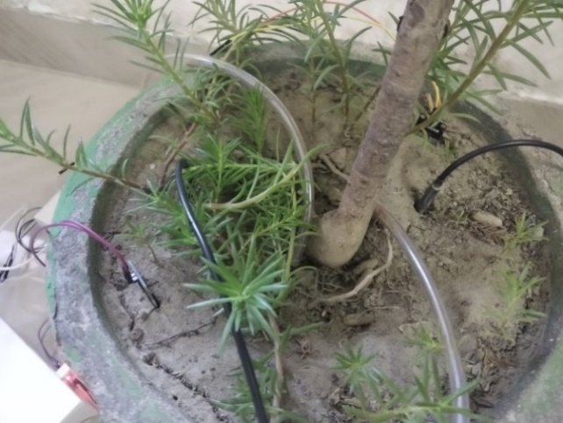

Figure 4(a) Installation of the sensors in a pot.

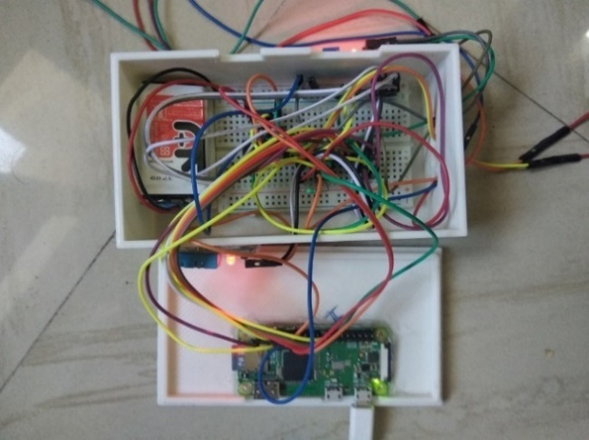

Figure 4(b) Connection to all sensor nodes.

# RESULTS AND DISCUSSIONS

In the proposed system several components are connected and sharing the information from different sensors to the server of the thingspeak. The observations of the sensors can also be viewed directly from the thingspeak channel. This study proposed the four different readings of the sensors, such as soil temperature, soil moisture, humidity, and atmospheric temperature.

The whole experiment has the reading value every minute. In this manuscript, the 30 minutes timespan is used to analyze the result of the experiment. The whole observations are stored in the format of CSV (Cascading Style Sheet). These observed readings can also be downloaded from the channel of the thingspeak. In Figure 5(a) of the surrounded temperature, it depicts the observed readings of the atmospheric temperature. The maximum temperature of the atmosphere is 29°C and the minimum temperature is 28°C. In the first quarter of the figure, there is a change in the temperature. Afterward, it goes down and remains constant for the next 20 minutes. The reason for the constant temperature is due to change in the atmospheric conditions like raining, hazy sunshine and maybe the cloudy weather.

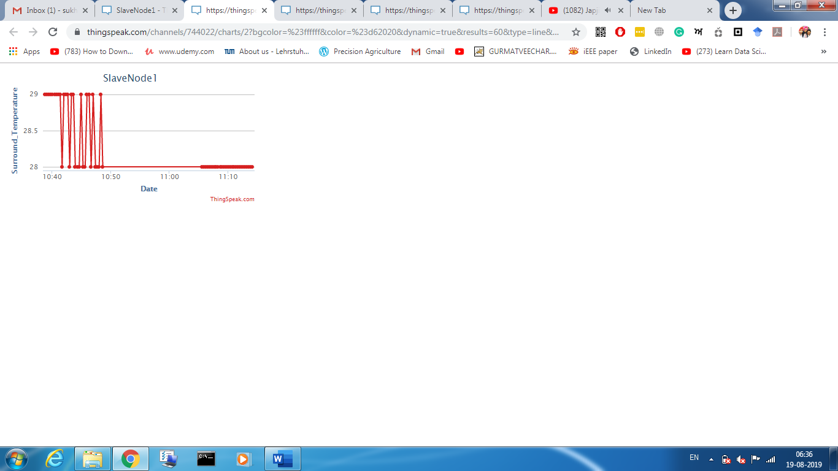

Figure 5(a): Surround Temperature.

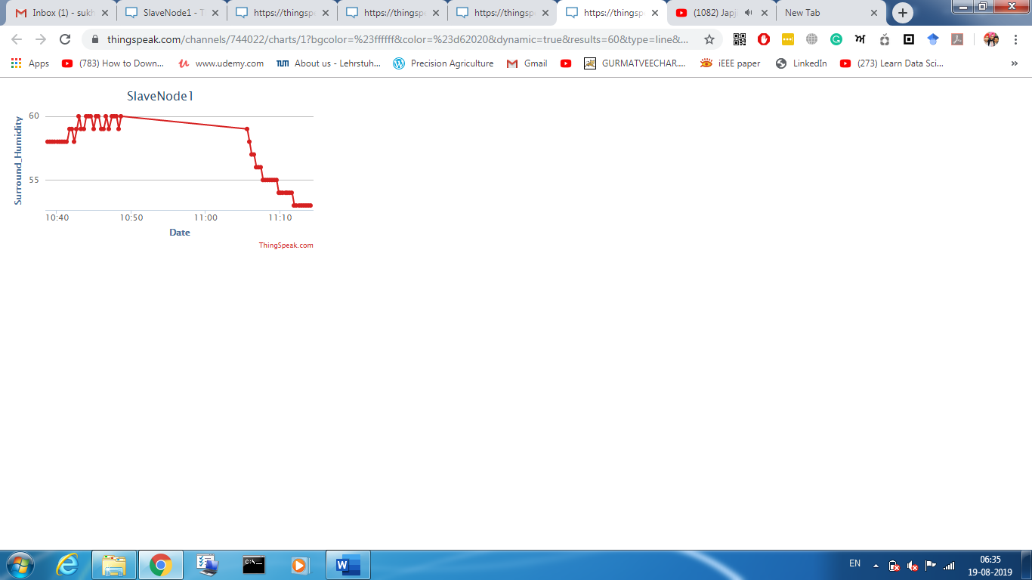

Figure 5(b) Surround Humidity.

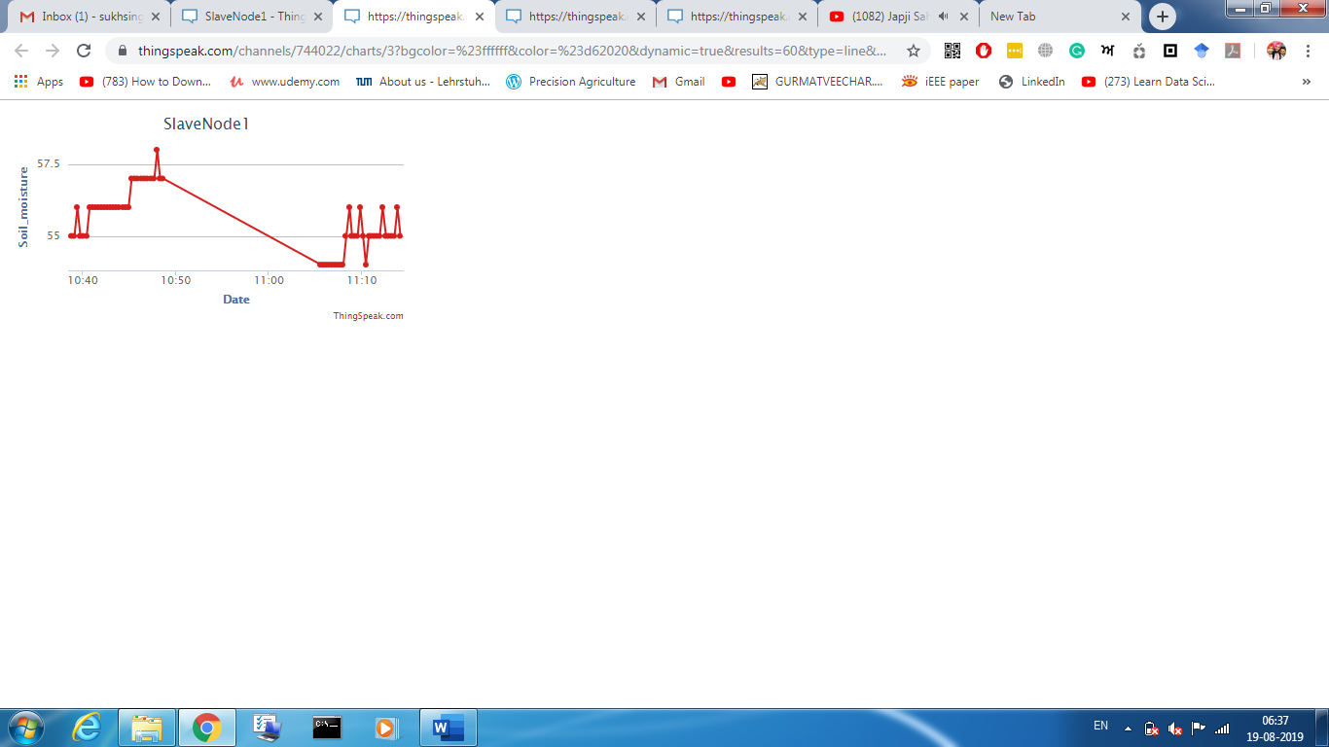

Figure 5(c): Soil moisture.

Figure 5(b) depicts the humidity level of the atmosphere in the unit of percent. The DHT sensor imports the readings from the environment and publishes it to the thingspeak. The humidity value at 10.55 is at the maximum level and after a certain minute, it moves downwards due to change in the room temperature or any atmospheric change.

The soil moisture is an important variable in precision agriculture. The readings of the soil moisture are fetched by the soil sensor installed within the soil. Figure 5(c) depicts the moisture readings of the soil moisture. The soil moisture is measured in terms of m/m3. Initially, the readings of the soil moisture is 55m/m3 in the figure and after 10 minutes it reached to the maximum level, but there is a decline in the moisture level because few drops of the water is added to the pot in which the sensors are installed and resulted in a change of temperature of the soil to 54 m/m3.

The temperature of the soil is depicted in Figure 5(d). There are many changes in the readings of the soil temperature. The first reading of the figure has a 26°C temperature and the last reading has 24.8°C. The average temperature level of the soil is 25°C in this experiment. In this study, there are four different types of data observations are created such as soil moisture, relative humidity, soil temperature, and atmospheric temperature. These data values are generated by sensors. A collective dataset of four different parameters is created of Patiala, India. A schema of the created dataset is summarized in Table 1.

.

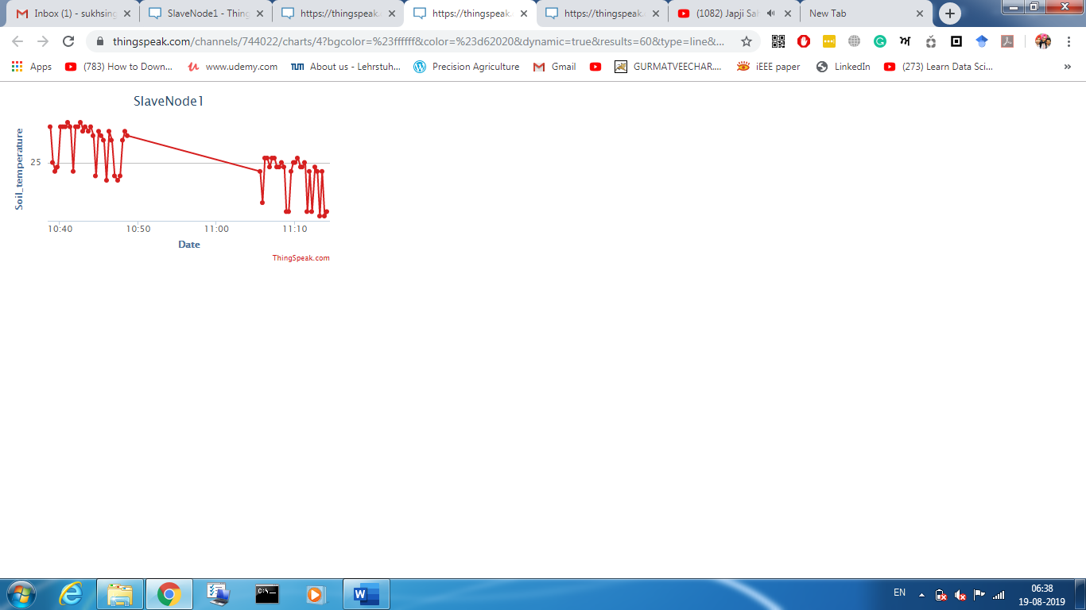

Figure 5(d) Soil temperature.

Table 1: Schema of the dataset.

|  |  |  |  |  |  |
| --- | --- | --- | --- | --- | --- |
| Date_  Time | Sr.  No | Relative Humidity | Atmos-pheric Temp-erature | Soil Moisture | Soil Temperature |

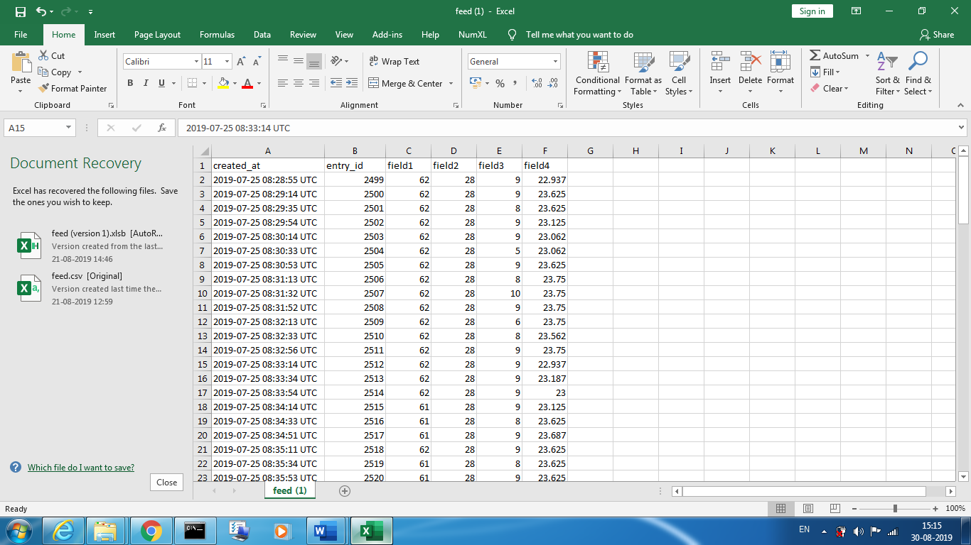

Figure 6: Dataset accumulated on thingspeak.

The above-depicted table has the 6 columns of the real-time data observations in the whole dataset. Initially, it has the date and time of the observation in the format of 24 hours. The sr_no has a record of consecutive transactions of the observations. The reading values created in this study such as relative humidity, atmospheric temperature, soil moisture, and soil temperature are added to the next column respectively. A snapshot of the available dataset is depicted in Figure 6. This figure shows that the reading values of all observations are exported online to the server of the thingspeak. These reading values can be visualized or analyze using any model of machine learning or deep learning.

# CONCLUSION AND FUTURE SCOPE

Precision agriculture is a new technology toward traditional agriculture. In the proposed study of agriculture, a sensor network system is presented in which all pieces of equipment are interconnected to raspberry devices (zero and 3B) and a channel is created to analyze the behavior of the soil and atmosphere. The network prototype of this study uses the real-time data of the soil moisture, soil temperature, humidity, and atmospheric temperature. The fetched reading of the different sensors is collected by the raspberry 3B device and another raspberry zero device is used to publish the readings to the cloud server of the thingspeak. The thingspeak is an online tool that provides analytical data services for IoT applications. The proposed system has proven that it is an effective and economical way to transmit the data of the field to the long-distance servers and analyze the behavior of the crop and field. In the future, several numbers of raspberry devices with the number of sensors are installed in a field to fetch the maximum number of observations of the soil and environment of the crop.

##### Acknowledgment

The authors would like to acknowledge the Council of Scientific and Industrial Research (CSIR) for funding grants vide No. 38(1464)/18/EMIR-II for carrying out research work.

##### References

[1] Kumar, K. Arun, and K. Ramudu. "Precision Agriculture using Internet of Things and Wireless sensor Networks." Precision Agriculture 7, no. 03 (2019).

[2] Andrew, Richard Charles, Reza Malekian, and Dijana Capeska Bogatinoska. "IoT solutions for precision agriculture." In 2018 41st International Convention on Information and Communication Technology, Electronics and Microelectronics (MIPRO), pp. 0345-0349. IEEE, 2018.

[3] Dholu, Manishkumar, and K. A. Ghodinde. "Internet of things (iot) for precision agriculture application." In 2018 2nd International Conference on Trends in Electronics and Informatics (ICOEI), pp. 339-342. IEEE, 2018.

[4] Vatari, Sheetal, Aarti Bakshi, and Tanvi Thakur. "Green house by using IOT and cloud computing." In 2016 IEEE International Conference on Recent Trends in Electronics, Information & Communication Technology (RTEICT), pp. 246-250. IEEE, 2016.

[5] Khot, Sandip Balaso, and M. S. Gaikwad. "Development of cloud-based Light intensity monitoring system for green house using Raspberry Pi." In 2016 International Conference on Computing Communication Control and automation (ICCUBEA), pp. 1-4. IEEE, 2016.